1. If , then the absolute value of *x* is

(A) 7

(B)

(C)

(D)

(E) 9

2. The sum of the third and fourth terms in a sequence of consecutive integers is 47. The sum of the first five terms of the sequence is

(A) 90

(B) 72

(C) 115

(D) 93

(E) 49

3. Given *y* > 0, *x* > *y*, and *z* ≠ 0, the inequality which is not always correct is

(A) *x*-*z* > *y*-*z*

(B) *xz* > *yz*

(C)

(D) *xz*2 > *yz*2

(E) None of these

4. If Alma wants to mail a package which requires $1.53 in postage, and has only 5-cent and 8-cent stamps, what is the smallest number of stamps she could use to total exactly $1.53?

(A) 24

(B) 23

(C) 21

(D) 14

(E) 17

5. If 4*x*-4*x*-1 = 24, then (2*x*)*x* is equal to

(A) $5\sqrt{5}$

(B) 25

(C) 125

(D)

(E) 5

6. If *y* = , then the largest possible value of *y* (for real *x*) is

(A) 1

(B) 2

(C) 3

(D) 0

(E) 2.5

7. Which number below is the greatest?

(A) 6100

(B) 5200

(C) 4300

(D) 3400

(E) 2500

8. On a dark and lonely night, a man is standing 5 meters away from a street light. The man is 2 meters tall and the light is 6 meters high. How long is the man's shadow?

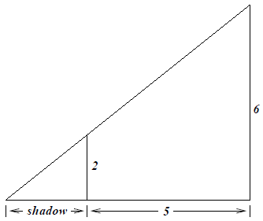

(A) 2 meters

(B) $\frac{7}{3}$ meters

(C) $\frac{5}{2}$ meters

(D) 4 meters

(E) 3 meters

9. The four angles of a quadrilateral inscribed in a circle are *α*; *β*; *γ* and *δ* as shown. Which of the following is necessarily true?

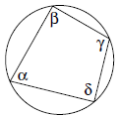

(A) *α*+*β*+*γ*+*δ* = 180 $°$

(B) *α*+*β* = 180 $°$

(C) *α*+*γ* = *β* +*δ*

(D) *β* +*δ =*90 $°$

(E) None of these

10. A bus travels up a hill at an average speed of 50 k.p.h. At what average speed would it have to travel down the hill to average 60 k.p.h. for the entire trip?

(A) 68

(B) 70

(C) 72

(D) 73

(E) None of these

11. The area of the largest triangle that can be inscribed in a semi-circle of radius *r* is

(A) *r*2

(B) 2*r*2

(C) 2*r*3

(D) 0.5*r*2

(E) 1.5*r*2

12. Expressing the answer only in rational numbers and square roots, the value of sec($\frac{7π}{12}$) is

(A)

(B)

(C)

(D)

(E)

13. In the circle with *O* as center, $∠$*BAC* = 15 $°$. Then $∠$*OBC* is

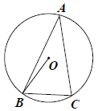

(A) 30 $°$

(B) 75 $°$

(C) 45 $°$

(D) 60

(E) 120

14. A cube measuring 100 units on each side is painted only on the outside and cut into unit cubes. The number of cubes with paint only on two sides is

(A) 1000

(B) 1125

(C) 1176

(D) 980

(E) 1100

15. The largest constant *C* such that sin *x* ≥ *Cx* for all *x* in [0; $\frac{π}{2}$] is

(A) 0

(B) 0.5

(C)

(D)

(E)

16. Circle *C* is tangent to line *l*. Two circles *C*1 and *C*2 of equal radii are each tangent to one another, to *C*, and to *l*. If the radius of *C* is 3, then the radius of *C*1 is

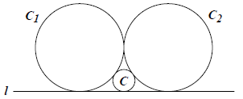

(A) 6

(B) 8

(C) 10

(D) 12

(E) 9

17. It takes a girl 90 minutes to mow her mother's yard and her brother can do it in 60 minutes. How long would it take them to mow if they worked together using the two mowers?

(A) 36 minutes

(B) 150 minutes

(C) 40 minutes

(D) 42 minutes

(E) 38 minutes

18. In the figure below, given that $θ$ = $\frac{π}{2}$ and that $\frac{a}{b}$ = $\frac{3}{2}$, the area ofthe circle in terms of *a* is

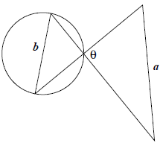

(A)

(B)

(C)

(D)

(E)

19. A lattice point in the plane is a point both of whose coordinates are integers. How many lattice points (including the endpoints) are there on the line segment joining the points (2, 0) and (16, 203)?

(A) 15

(B) 8

(C) 9

(D) 14

(E) 15

20. For what values of a does the system of equations $\left\{\begin{matrix}x^{2}=y^{2} \\ {(x-a)}^{2}+y^{2}=1\end{matrix}\right.$ have exactly 3 solutions?

(A) For all $a≥0$

(B) For $-2≤a≤2$

(C) For $a=±1$

(D) For $a∈\left\{-1, 0, 1\right\}$

(E) None of these

21. Five counterfeit coins are mixed with nine authentic coins. If two coins are drawn at random, the probability that one is good and one is counterfeit is

(A)

(B)

(C)

(D)

(E)

22. Reading from left to right, the 8th digit of the product 7216848248168566432×125 is

(A) 1

(B) 4

(C) 5

(D) 6

(E) None of these

23. Given a square whose sides have length 2*a*, find the area of the region bounded by the 4 semi-circles which are in the interior of the square and have the four sides of the square as diameters.

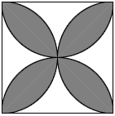

(A)

(B)

(C)

(D)

(E)

24. In the rectangle below, let *p* be the point in its interior with the distances from the four corners as shown. The value of *x* is

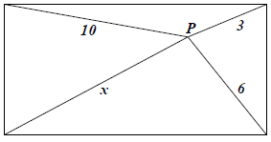

(A) 13

(B)

(C) 7

(D)

(E)

25. A sum of 35 integers is *S*. Two digits in one of the integers are interchanged and a new sum *T* is produced. Then the difference *S*-*T* is necessarily divisible by

(A) 9

(B) 2

(C) 7

(D) 5

(E) 14

26. The locus of points equidistant from the circle *x*2+*y*2 = 1 and the line *y* = -3 is given by the graph of

(A) *y*+2 = 3*x*2

(B) *y*+2 = -3*x*2

(C) *x*2+*y*2-1 = (*y*+3)2

(D) *x*2+*y*2 = (*y*+4)2

(E) *x*2+*y*2-2 = (*y*+3)3

27. In the configuration below consisting of 36 one-by-one squares, how many total squares with horizontal and vertical sides can be formed using the points as vertices?



(A) 88

(B) 89

(C) 90

(D) 91

(E) 92

28. The number of solutions, in real numbers $x_{1},x_{2},x_{3},$ to the system of equations $\left\{\begin{aligned}x_{1}+x_{2}x_{3}=1 \\ x_{2}+x_{1}x_{3}=1 \\ x_{3}+x_{1}x_{2}=1\end{aligned}\right.$ is

(A) Zero

(B) 3

(C) 4

(D) More than 4, but finitely many

(E) Infinitely many

29. Let be the normal line to *y* = *x*2 at (*u*; *u*2). Let (0; *bu*) be the *y*-intercept of $l_{u}$. Then $\lim_{u→0}{b_{u}}$ is

(A) 0

(B) 0.5

(C) 1

(D) ∞

(E) 2

30. is

(A) *e*-1

(B) *e*

(C)

(D) 1

(E) 2*e*